ES37A: Medical Management Form: Anaphylaxis
Applicable to Community Language Schools SA and all member schools

When completing this form please seek your medical practitioner’s advice.
The following information is required to assist in the proper management of your child’s Anaphylaxis. Please complete and return to the school with a medical plan from your medical practitioner. |  |  |  | Place photograph of the student. This will assist staff identifying your child in the event of an Anaphylaxis attack.
Student’s name:
Date of Birth:
Usual signs of Anaphylaxis
Wheezing | Chest tightness | Coughing
Difficulty breathing | Difficulty speaking | Dizziness
Hives | Rash | Swelling
Other:
Usual medical regime or program to be followed in the event of Anaphylaxis:
Name of Medication: |  | Method:
Dose: |  | Frequency/time to be taken:
 | Does your child require assistance to take their medication Yes No
Has your child been admitted to hospital due to Anaphylaxis in the past 12 months? Yes No
Has your child ever suffered sudden severe Anaphylaxis requiring hospitalisation? Yes No
Important Notes
If you have answered “yes” to the above questions then a letter from your child’s doctor must accompany this form, outlining the personal Anaphylaxis Action Plan.
I declare that the information provided on this form is complete and correct.
I acknowledge that in the event of a crisis situation emergency services will be called and that I will pay any costs incurred

Parent/guardian:

Phone contact(s): OR

Signature: Date:
Privacy Disclaimer
The school acknowledges and respects the privacy of its community. The information that is being collect by the school is to process your enrolment. By completing this form, you have consented to this information being collected. The intended recipients of this information are the school, Community Language Schools SA. and for interaction with the Government of South Australia who provide funding to community language schools. The information collected will not be released for any form of commercial gain and will be maintained in a secure location as per the requirements of the Privacy Act 1988. You have the right to access and alter personal information concerning yourself or your child in accordance with the Privacy Act 1988 and the school’s record management policy. The contact information of students will be shared publicly only when the express permission is given to Community Language Schools SA to do so or under mandatory reporting requirements.

Image source: Asthma Australia https://www.asthmaaustralia.org.au/sa/about-asthma/asthma-emergency

ES37A: Medical Management Form: Asthma
Applicable to Community Language Schools SA and all member schools

When completing this form please seek your medical practitioner’s advice.
The following information is required to assist in the proper management of your child’s Asthma. Please complete and return to the school with a medical plan from your medical practitioner. |  |  | Place photograph of the student. This will assist staff identifying your child in the event of an Asthma attack.
Student’s name:
Date of Birth:
Usual signs of Asthma
Wheezing | Chest tightness | Coughing
Difficulty breathing | Difficulty speaking
Other:
Usual medical regime or program to be followed in the event of Asthma Attack:
Name of Medication: |  | Method:
Dose: |  | Frequency/time to be taken:
Does your child require assistance to take their medication: Yes No

Signs of worsening Asthma:

Medication and treatment to be used during worsening Asthma:

List any known Asthma triggers:

Has your child been admitted to hospital due to Asthma in the past 12 months? Yes No
Has your child been on oral cortisone for Asthma within the past 12 months? (e.g. Prednisolone, Cortisone, Betamethasone etc) Yes No
Has your child ever suffered sudden severe Asthma attacks requiring hospitalisation? Yes No

Important Notes
If you have answered “yes” to the above questions then a letter from your child’s doctor must accompany this form, outlining the personal Asthma Action Plan.

Asthma Management Form
I declare that the information provided on this form is complete and correct.
I acknowledge that in the event of a crisis situation emergency services will be called and that I will pay any costs incurred.
I agree to the following first aid procedures to be carried out in the event of an Asthma Attack.

Parent/guardian:

Phone contact(s): OR

Signature: Date:
Asthma Management Plan
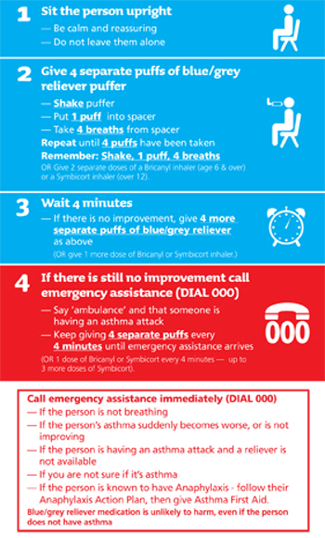
Image Source: https://www.asthmaaustralia.org.au/sa/about-asthma/resources
Privacy Disclaimer
The school acknowledges and respects the privacy of its community. The information that is being collect by the school is to process your enrolment. By completing this form, you have consented to this information being collected. The intended recipients of this information are the school, Community Language Schools SA. and for interaction with the Government of South Australia who provide funding to community language schools. The information collected will not be released for any form of commercial gain and will be maintained in a secure location as per the requirements of the Privacy Act 1988. You have the right to access and alter personal information concerning yourself or your child in accordance with the Privacy Act 1988 and the school’s record management policy. The contact information of students will be shared publicly only when the express permission is given to Community Language Schools SA to do so or under mandatory reporting requirements.

ES37A: Medical Management Form: Diabetes
Applicable to Community Language Schools SA and all member schools

When completing this form please seek your medical practitioner’s advice.
The following information is required to assist in the proper management of your child’s Diabetes. Please complete and return to the school with a medical plan from your medical practitioner. |  |  |  | Place photograph of the student. This will assist staff identifying your child in the event of a diabetic episode.
Student’s name:
Date of Birth:
Usual signs of Hypo
extreme thirst | fatigue | blurred
pale | hungry | sweating
weak | confused | aggressive
Other:
I _____________________________________ consent to the following treatment if my child displays symptoms of a hypo:
Give sugar (jelly bean)
Give sugar ( sweet drink)
Continue to give sugar every 15 minutes until recovered
Provide sandwich or other food
Call 000
Other:

Usual signs of a Hyper
Thirsty | Frequent need to urinate | Hot dry skin |  | Smell of acetone on breath
I ________________________________ consent to the following treatment if my child displays symptoms of a hyper:
Give water
Call 000
Other:

Medication and Equipment:
Type of Medication
When is Medication to be administered
Dose Required
How often does your child need to check their Blood Glucose Levels/Insulin Levels?
Does your child require assistance to take their medication Yes No

Emergency Contact Details:
In the event of your child having trouble managing their diabetes, the following people are to be contacted
Emergency Contact 1:
Name: |  | Phone Number:
Mobile Phone: |  | Relationship to Student:
Emergency Contact 2:
Name: |  | Phone Number:
Mobile Phone: |  | Relationship to Student:
Medical Practitioner:
Doctor’s Name: |  | Phone Number:

I declare that the information provided on this form is complete and correct.
I acknowledge that in the event of a crisis situation emergency services will be called and that I will pay any costs incurred
Parent/guardian:

Phone contact(s): OR

Signature: Date:

Image source: Asthma Australia https://www.asthmaaustralia.org.au/sa/about-asthma/asthma-emergency

Privacy Disclaimer
The school acknowledges and respects the privacy of its community. The information that is being collect by the school is to process your enrolment. By completing this form, you have consented to this information being collected. The intended recipients of this information are the school, Community Language Schools SA. and for interaction with the Government of South Australia who provide funding to community language schools. The information collected will not be released for any form of commercial gain and will be maintained in a secure location as per the requirements of the Privacy Act 1988. You have the right to access and alter personal information concerning yourself or your child in accordance with the Privacy Act 1988 and the school’s record management policy. The contact information of students will be shared publicly only when the express permission is given to Community Language Schools SA to do so or under mandatory reporting requirements.

.

ES37A: Medical Management Form: Epilepsy
Applicable to Community Language Schools SA and all member schools

When completing this form please seek your medical practitioner’s advice.
The following information is required to assist in the proper management of your child’s Epilepsy. Please complete and return to the school with a medical plan from your medical practitioner. |  | Place photograph of the student. This will assist staff identifying your child in the event of a seizure.
Student’s name:
Date of Birth:
Medication
Type of Medication:
When is Medication to be administered:
Does Required:
Does your child require assistance to take their medication Yes No

Emergency Contact Details:
In the event of your child having a seizure, the following people are to be contacted:
Emergency Contact 1:
Name: |  | Phone Number:
Mobile Phone: |  | Relationship to Student:
Emergency Contact 2:
Name: |  | Phone Number:
Mobile Phone: |  | Relationship to Student:
Medical Practitioner:
Doctor’s Name: |  | Phone Number:

I declare that the information provided on this form is complete and correct.
I acknowledge that in the event of a crisis situation emergency services will be called and that I will pay any costs incurred
I agree to the following first aid procedures to be carried out in the event that my child has a seizure

Parent/guardian:

Phone contact(s): OR

Signature: Date:
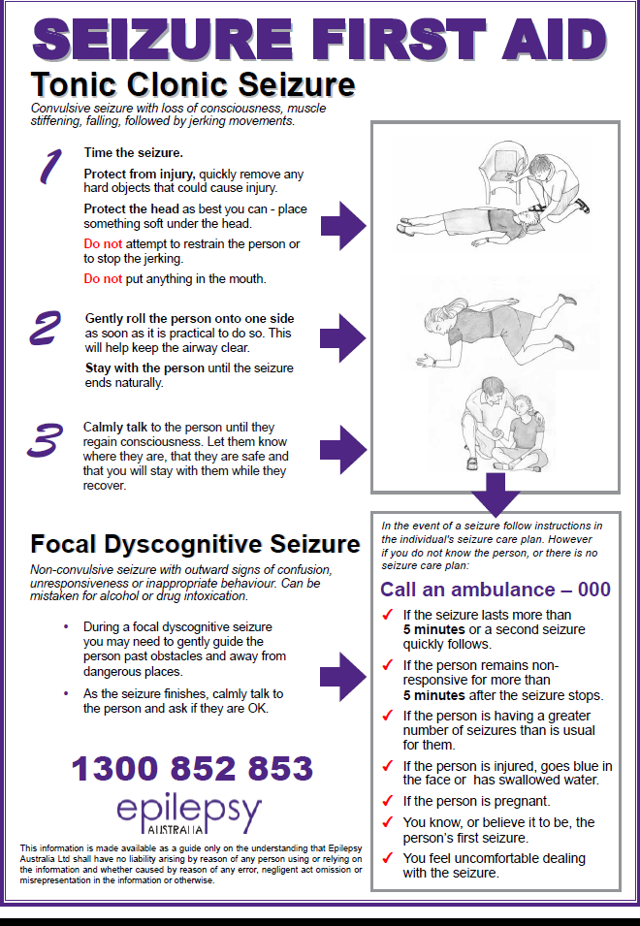

Image Source: http://www.epilepsyaustralia.net/seizure-first-aid/

Privacy Disclaimer
The school acknowledges and respects the privacy of its community. The information that is being collect by the school is to process your enrolment. By completing this form, you have consented to this information being collected. The intended recipients of this information are the school, Community Language Schools SA. and for interaction with the Government of South Australia who provide funding to community language schools. The information collected will not be released for any form of commercial gain and will be maintained in a secure location as per the requirements of the Privacy Act 1988. You have the right to access and alter personal information concerning yourself or your child in accordance with the Privacy Act 1988 and the school’s record management policy. The contact information of students will be shared publicly only when the express permission is given to Community Language Schools SA to do so or under mandatory reporting requirements.

